WIKI-AM,C-Taino-Ceremonial Celts

Ceremonial celts of a petuloid shape without an attached figure are highly polished of local metamorphic stone. They may have mythic significance as a celt was used to free mother tortoise, the progenitor of Mankind. They were also used for ceremonial purposes, as none have marks of use-wear. Since they were large, some, like this example, being over a foot in length, were presumably intended for élite consumption. The distribution of highly polished celts extends from the Bahamas to Trinidad, suggesting a sophisticated system of trade and exchange of élite ceremonial objects among caciques in efforts to establish alliances or exchange of such objects as means of currency (Roberts 2014: 163).

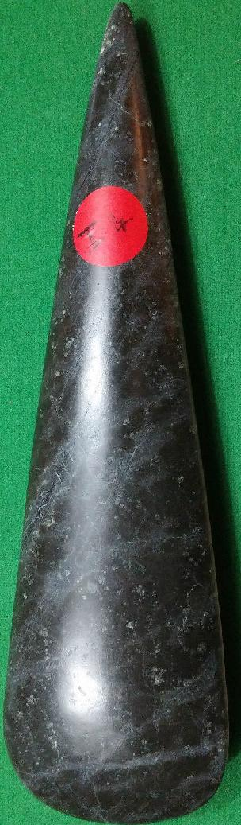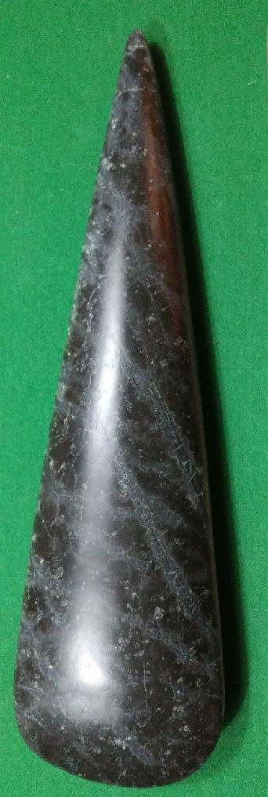

Taino Ceremonial Celt of Porphyry from the Dominican Republic. Length: 12 3/16 in.

# References:

# Roberts, Larry. 2014. *Taino Sculpture: art of the gods* (Micanopy, Florida: Signature Book Printing)

# Order details

## Sales order

Sold by [user1billion](http://myworld.ebay.com/user1billion) ( [791](http://feedback.ebay.com/ws/eBayISAPI.dll?ViewFeedback&userid=user1billion) )

### Delivery package 1 of 1

Estimated delivery Wednesday, Feb 3, 2016 - Wednesday, Feb 10, 2016

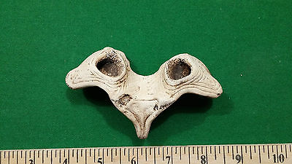

#### [Taino Pendent - Pre Columbian](http://www.ebay.com/itm/161947506881)

|  |  |
| --- | --- |
| Item price | $89.00 |
| Quantity | 1 |
| Item number | 161947506881 |
| Shipping service | Standard Int'l Shipping |

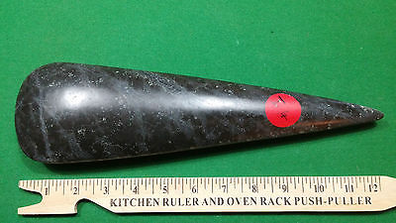

#### [Taino Stone Carving highly polished Cerimonial Axe](http://www.ebay.com/itm/272105571459)

|  |  |
| --- | --- |
| Item price | $199.00 |
| Quantity | 1 |
| Item number | 272105571459 |
| Shipping service | Standard Int'l Shipping |

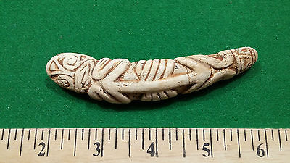

#### [Taino Carved Pendent - Pre Columbian](http://www.ebay.com/itm/272105659692)

|  |  |
| --- | --- |
| Item price | $129.00 |
| Quantity | 1 |
| Item number | 272105659692 |
| Shipping service | Standard Int'l Shipping |